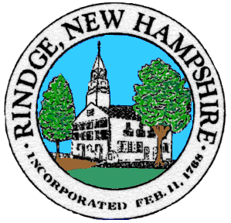 | RINDGE BOARD OF ADJUSTMENT  30 PAYSON HILL ROAD  RINDGE NH 03461  PH. (603) 899-5181 x 105 FAX (603) 899-2101 TDD 1-800-735-2964  www.rindge.nh.org

Town of Rindge Zoning Board of Adjustment
NOTICE OF PUBLIC HEARING

Notice is hereby given that on Tuesday, February 27, 2024, at 7:00 p.m., the Zoning Board of Adjustment will hold the following Public Hearing at the Rindge Town Office, 30 Payson Hill Road, Rindge, NH 03461:

Case 2017 James and Lisa Trautwein, 16 Quimby Road, Rindge, NH for property located at 16 Quimby Road, Rindge NH 03461, Tax Map 5, Lot 25 in the Residential- Agricultural District, for a Variance from Section 5a of the Wetlands Ordinance for increasing impervious area within fifty feet of vegetated wetlands, to wit: demolishing dwelling 24x36 with six inch roof overhangs (925 sq. ft. impervious), replace with dwelling 24x43 with twelve inch roof overhangs (1170 sq. ft. impervious). About 60% of the structures are within the 50’buffer (1170-925) x.6=147 sq. ft. increase in impervious area.

Approval of Minutes: September 27, 2023 & October 25, 2023
Other business that may come before the Board:
If you cannot attend the hearing and would like your opinion(s) entered in the Board of Adjustment's files for the case, you may send a letter to the Board documenting your input/testimony. Leave any documentation with the Zoning Clerk for presentation at the hearing of the Board of Adjustment.
Kim McCummings
Zoningclerk@rindgenh.org

