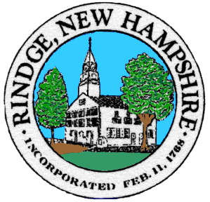
Board of Selectmen Meeting

*The Selectmen are holding a hybrid meeting in person at the Meeting House and online via Zoom to accommodate all residents. The physical address is 6 Payson Hill Rd, Rindge NH 03461.

VIA ZOOM: Join meeting CLICK HERE or call: 1.253.215.8782 or 1.301.715.8592
Meeting ID: 684 000 2706
Password: 434015

Please call 603-562-6190 or email KJPRindge@gmail.com with any problems accessing the meeting

Please note you must identify yourself upon logging in to the Board of Selectmen Zoom meeting. If you are unable to identify yourself properly you may not be permitted to attend the meeting.

Wednesday, 04/14/2021

Non Public Meeting 5:30

6:00 PM Via Zoom

Agenda

Selectmen’s Announcements: E-Meeting announcement
Citizen’s Forum

Consent Agenda
- Approval of:
- Minutes 3/31/2021
- Payroll 4/8/2021, 4/15/2021
- Accounts payable 4/8/2021, 4/15/2021
- Annual Farmer’s Market: West Rindge Common Park
- Ingalls Memorial Trustee Appointment:
Richard Isakson
Jeff Dickler

- Old Business
- Consolidated Communications

- New Business
- Paving
- Administrative Abatement Map 3 Lot 92-9
- Abatement Schedule

- Informational Items/Communications/Updates

Any other official business to come before the Board

