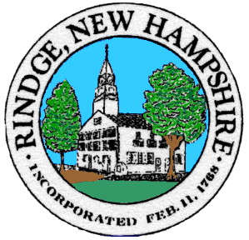
Board of Selectmen Meeting

Town Office Conference Room

Wednesday, 4/27/2022

5:00 PM Non Public session

6:00 PM re-open Public session

Agenda
Pledge of Allegiance

Selectmen’s Announcements:

Citizen’s Forum

Consent Agenda
- Approval of:
- Minutes 4/13/2022 Public Session, 4/13/2022 Non Public Sessions
- Payroll 4/21/2022, 4/28/2022
- Accounts payable 4/21/2022, 4/28/2022
- Intent to Cut Map 4, Lot 46
- Intent to Cut Map 2, Lot 10, 74, Map 6 Lots 4, 100
- Intent to Cut Map 11, Lot 33
- Camper Permit Map 19, Lot 9
- CNBRLAC member reappointment: Brian Maloy

- Old Business
- ARPA

- New Business

- Informational Items/Communications/Updates

Any other official business to come before the Board

