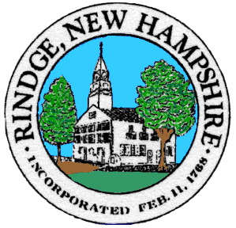
Board of Selectmen Meeting

Town Office Conference Room

Wednesday, 5/25/2022

5:30 PM Non Public session
6:00 PM re-open Public session

Agenda
Pledge of Allegiance

Selectmen’s Announcements:

Citizen’s Forum

Consent Agenda
- Approval of:
- Minutes 5/11/2022 Public Session, 5/11/2022 Non Public Sessions
- Payroll 5/19/2022, 5/26/2022
- Accounts payable 5/19/2022, 5/26/2022
- Appointment of Forest Fire Warden
- Appointment of Daniel Bissex to Energy Commission
- Ingalls Memorial Library Board of Trustee Alternates:
Richard Isakson
Taylor Ratcliffe
- Special Event Permit: Memorial Day Commemoration 5/30/2022
- Special Event Permit: Yard and Plant Sale 6/4/2022

- Old Business
- ARPA
- Signature on Gift Deed for Thomas Clock

- New Business
- Postage Meter Contract
- Paving Bid Recommendation
- Brush Clearing for July 4th Event

- Informational Items/Communications/Updates

Any other official business to come before the Board

