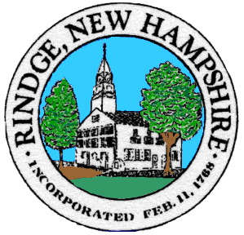
Board of Selectmen Meeting
Town Office
Wednesday, __1/26/2022_

__6:00__ PM Public Meeting
Agenda
Pledge of Allegiance

Selectmen’s Announcements:

Citizen’s Forum

Consent Agenda
- Approval of:
- Minutes 1/18/2022, 1/19/2022
- Payroll 1/27/2022
- Accounts payable 1/13/2022, 1/27/2022

- Old Business
  - Finalize Warrant Articles
  - KRT Settlement Recommendations

- New Business
  - Safer Grant for additional fire fighter(s)
  - Grants and donations
  - Who will be presenting the Warrant Articles at Deliberative Session?

- Informational Items/Communications/Updates

Any other official business to come before the Board

