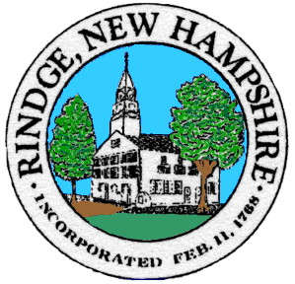
Board of Selectmen Meeting
Meeting House
Wednesday, __12/22/2021_

__5__PM Non-Public Meeting

__6__ PM Public Meeting
Agenda
Pledge of Allegiance

Selectmen’s Announcements:

Citizen’s Forum

Consent Agenda
- Approval of:
- Minutes 12/8/2021,
- Payroll 12/16/2021, 12/23/2021
- Accounts payable 12/16/2021, 12/23/2021
- Intent to cut Annett State Forest

- Old Business
- KRT’s contract and BTLA mediation results/information that was due on 12/01/2021

- New Business
- BAC Recommendations (open enrollment benefits)

- Informational Items/Communications/Updates

Any other official business to come before the Board

