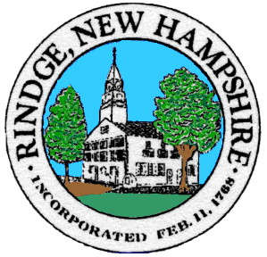
Board of Selectmen Meeting

Rindge Meetinghouse

Wednesday, 5/11/2022

5:30 PM Non Public session
Special Swearing In Ceremony 6PM
6:00 PM re-open Public session

Agenda
Pledge of Allegiance

Selectmen’s Announcements:

Citizen’s Forum

Consent Agenda
- Approval of:
- Minutes 4/27/2022 Public Session, 4/27/2022 Non Public Sessions
- Payroll 5/5/2022, 5/12/2022
- Accounts payable 5/5/2022, 5/12/2022
- Intent to Cut Map 4, Lot 46
- Intent to Cut Map 2, Lot 10, 74, Map 6 Lots 4, 100
- Intent to Cut Map 11, Lot 33
- Intent to Cut Map 10, Lot 30
- Intent to Cut Map 2, Lot 74
- Farmer Market Cabana Falls Liquor Request

- Old Business
- Thomas Clock and Thomas Clock Gift Deed

- New Business
- Irving Selectmen Sign off
- Trustees Request Letter
- Expenditure Review March 2022

- Informational Items/Communications/Updates

Any other official business to come before the Board

