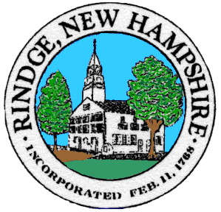
Board of Selectmen Meeting
Meeting House
Wednesday, __12/8/2021___

__6__ PM Public Meeting
Agenda
Pledge of Allegiance

Selectmen’s Announcements:

Citizen’s Forum

Consent Agenda
- Approval of:
- Minutes 11/17/2021, 12/3/2021
- Non Public Minutes 11/17/2021 Sessions #1, #2, #3, #5, 12/3/2021
- Payroll 11/26/2021, 12/2/2021, 12/9/2021
- Accounts payable 11/26/2021,12/2/2021, 12/9/2021
- Intent to cut M6 L34-2, 34-3

- Old Business
- KRT’s contract and BTLA mediation results/information that was due on 12/01/2021

- New Business
- New Hire
- Holiday Schedule
- Flex Spending Account Increase Maximums
- Money Transfer for Cruiser Maintenance
- Approval to expend $3,000 from the “Buildings Maintenance Fund” to get the Meeting House re-assessed in order to apply for Moose Plate and LCHIP grants which could total $45,000 to possibly maintain the clock and paint the steeple in 2022
- Acceptance of Roy A Hunt Foundation’s Trustees Grant of $5,000 (RSA 31:95b)
- Grant for Energy Assessment of Recreation Department
- ARPA for HRV System for Town Hall
- Joint meeting with BOS and CIP

- Informational Items/Communications/Updates

Any other official business to come before the Board

